Sending part of an Excel File (for example, sending one worksheet within an Excel File)

- Add the icon called ‘Send to Mail Recipient’ to your Excel Quick Access Toolbar. To check to see if the icon is present, go into MicroSoft Excel and look at the top left hand corner of your screen and find the quick access toolbar. It will be present but may not include the ‘Send to Mail Recipient’ icon. However, it’s quite easy to add the icon to your quick access toolbar.

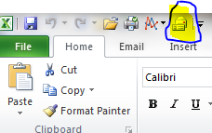

- To add the ‘Send to Mail Recipient’ icon to your ‘Quick Access Toolbar’.
  - Go into Excel
  - Left mouse click on the down arrow to the right of the quick access icons (see example below)
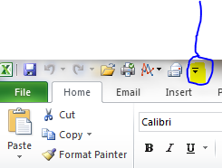
  - Select the option – More Commands
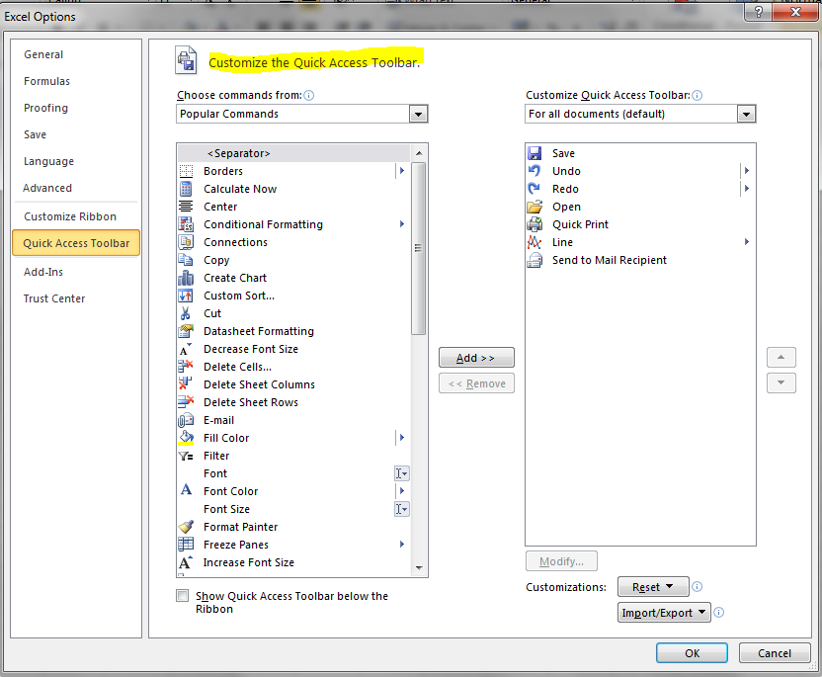

  - From the drop down window select the option called ‘All Commands’
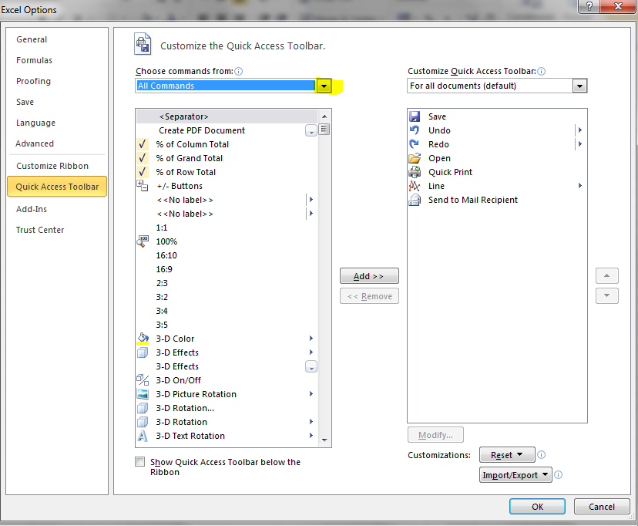
  - Using the drop down page down using the slide bar until you come across the icon called ‘Send to Mail Recipient’. When found, left mouse click on the icon to highlight it and then to the right press the Add button. This will move the icon to the right hand panel. When added the press the OK button.

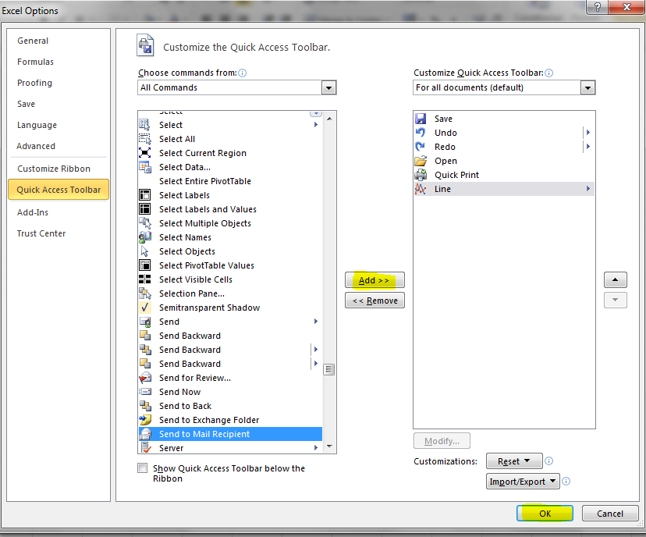

  - The icon will now be found within your Excel spreadsheet on the ‘Quick Access’ Toolbar.
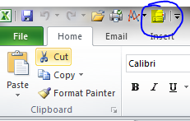

  - The process to send one individual work sheet to a mail recipient can now begin.
  - In the example spreadsheet below you will see an Excel file with three work sheets
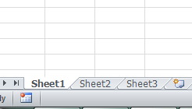

  - When in the work sheet you wish to send to a specific mail recipient press the ‘Send to Mail Recipient’ icon
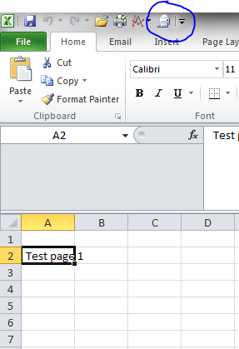

  - You will be provided with a ‘send to mail’ page. Complete the details providing the mail address of the recipient, the subject line, and you will note the work sheet is already included. When ready, press the ‘Send this sheet’ button Send this sheet.
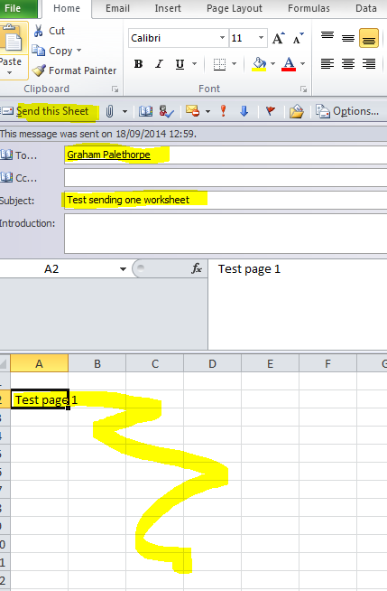

  - The work sheet only will be sent to the mail recipient.
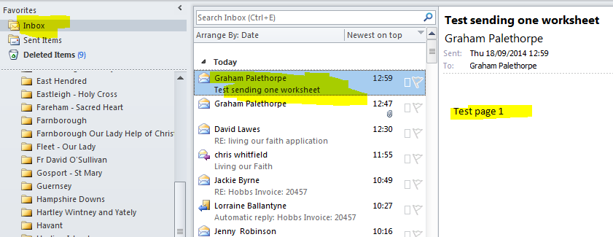
  - You can then quickly repeat the process for every other work sheet you have within the Excel file.

