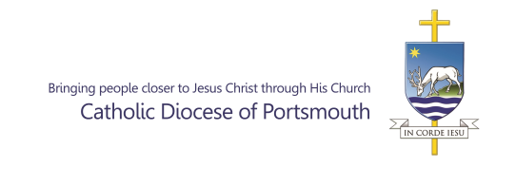
Guide for Parish Safeguarding Ministers (PSM’s) - DBS checks – all eligible roles.

Please note, PSM’s will still retain responsibility for recruitment of volunteers, including obtaining references.

- PSM to provide applicant with:

- DBS3a/DBS3b – Confirmation of Identity
- DBS3 guidance notes
- DBS4 – Safeguarding Self Declaration
- DBS4 - Guidance Notes
- DBS17 – Applicant consent to processing

- Applicant to complete all forms (using the guidance to ensure accuracy of information required) and make an appointment with PSM for ID verification to be completed.

- PSM to complete DBS3a/3b form and ID verification, checking all forms are completed as required and signed by the applicant BY HAND.

- PSM to take copies of identity documents provided and send these along with completed DBS3a/3b, DBS4 and DBS17 forms to:

Diocesan Safeguarding Office
St Edmunds House
Bishop Crispian Way
Portsmouth
PO1 3QA

Any postage costs incurred can be reclaimed via the parish office. Alternatively, documents can be sent using parish office resources.

If a PSM has access to scanning equipment then all forms and documents may be scanned and sent to safeguarding@portsmouthdiocese.org.uk

Please note: if scanning forms/documents these need to be scanned individually as single documents (eg all pages of the DBS4 would be one document). Please do not send a single continuous scan of all documents or photographs of documents.

- The Diocesan Safeguarding Office will manage the DBS process following receipt of the documents including creating the checklist and sending the online link for the applicant to complete, updating Safesys, countersigning and then submitting the application to the DBS.

- Upon notification of a check being complete, the Diocesan Safeguarding Office will inform the applicant and the PSM if cleared for role. Certificates are sent straight to the applicant by the DBS. Where there is a blemish, this will be known only to the applicant and the Diocesan Safeguarding Office who will follow the required process.

- If the applicant is a recheck and they are registered for the update service, only a new DBS4 Safeguarding Self Declaration is required. If they are not registered, the full process as above will be required.

