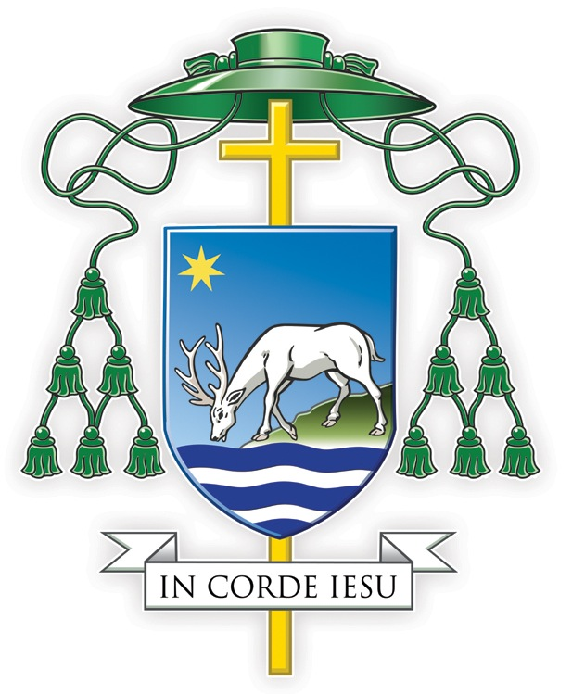

MESSAGE FROM BISHOP PHILIP

to the Clergy and Faithful of the Diocese of Portsmouth

Dear Brothers and Sisters in the Lord,
Earlier this week, the Government relaxed many of the restrictions it put in place because of the pandemic. Even so, the virus continues to be present, and as a Diocese, we will need to continue creating safe environments in our parish churches and properties, so that everyone, particularly the elderly and the vulnerable, can visit church, participate in Mass and share in parish life, safely and with confidence. (For the guidance we have issued to enable this, see here.)
The noble mission of our Diocese is: Bringing People Closer to Jesus Christ through His Church. It is in our churches that the Lord unites us together, sanctifies, teaches and guides us, and feeds us with the Sacraments of eternal life, sending us out on mission and service. During the lockdowns, many have followed Mass online and we thank God for all who helped to make that possible. But online is not the same as ‘inline.’ It’s not the same as being there, as actually receiving Jesus in Holy Communion. It’s not the same as sharing with our brothers and sisters in the life and mission of the eucharistic community.
This is why I wish to say to everyone: Now is the time to come back to the Lord to be nourished by His Word and Sacraments! Now is the time for everyone to return to church. The Lord is calling to us in our hearts: “The sheep that belong to me listen to my voice” (John 10: 27). He promises: “Anyone who eats my flesh and drinks my blood lives in me and I in him” (John 6: 56). He says: “I have come that they may have life and have it to the full” (John 10: 10). As Catholics, we do not follow Christ Jesus simply out of habit or obligation. We follow him because we love him. We follow him because he calls us. We follow him because he is our Saviour: He laid down His life for us. So I now say to you and to all: Come back to the Lord in Sunday Mass. Come to be nourished by his Word and his Sacraments!
Thank you for listening – and please be assured of my prayers.

In Corde Iesu,
+Philip
Bishop of Portsmouth

