

Diocesan Operating Procedures - A Finance and Accounting - Curia

*“Good planning and hard work lead to prosperity, but hasty shortcuts lead to poverty.”*

***Proverbs 21:5***

Issued by:

The Bishop of Portsmouth and the Trustees of the Portsmouth Diocesan Trust St Edmund House

Bishop Crispian Way Portsmouth PO1 3QA

Registered Charity No. 246871

**INTRODUCTION**

The Diocesan Finance and Accounting Operating Procedures (DoPs) A are provided as guidance to managers volunteers and to employees on how a wide range of issues should be managed in relation to Finance.

The underlying rationale to DoPs A is to provide a framework of policies and procedures which provide a way of working within the concept regulatory requirements.

It also provides employees, volunteers and line managers with relevant forms, letters, and documents in a series of appendices for use in the appropriate circumstances.

**Finance Policies** provide general and practical advice as well as guidance on a range of issues to ensure all employees (and volunteers) act appropriately as required by the Diocese and in adherence to relevant legislation.

**Finance Procedures** support and supplement the policies by giving a step- by-step account of specific arrangements that apply in particular circumstances.

**Forms and Guidance** notes are also provided throughout relating to the policies and procedures.

**Please note that these policies and the accompanying procedures and forms are for guidance only. They do not have contractual status as they may be amended from time to time.**

**FOREWORD**

God’s Church here in the Diocese of Portsmouth is formed of many and varied communities, held together in the same Truth of Christ both in doctrine life and worship. We need common operating procedures across the Diocese to ensure compliance with the needs of both canon and civil law. In addition, and especially in the light of the church’s call to the work of new evangelisation, we need to ensure harmonised collaboration. We have a responsibility to ensure that people, buildings, and money are treated carefully allowing us to perform our duties “with the diligence of a good householder” (Canon 1284§1).

So, I present to you an updated version of our Diocesan Operating Procedures for Finance and Accounting (DoPs) A. These have the status of particular law for the Diocese of Portsmouth. They must be understood and followed in the broad areas of human resource, schools, buildings, and finance.

I am very grateful to all those who have compiled these procedures and ensure their regular review and updating.

In Corde Iesu

+Bishop Egan

Bishop of Portsmouth

**TERMINOLOGY**

Throughout this DoPs, the Portsmouth Roman Catholic Diocese will be referred to as **‘the Diocese’**. This expression shall include any representative acting for or on behalf of the Diocese Trustees, for example Finance Manager, Line Managers or any other representative appointed to carry out work on behalf of The Portsmouth Roman Catholic Diocese.

Throughout this DoP the expression, **‘Line Manager’**, will be used which may be referring to a Co-ordinating Pastor/Parish Priest/Head of Department or any other person with line management responsibilities.

This DoP is subject to changes brought about by relevant legislation, regulations and changes in best practice. Any changes and amendments that may be made to this document will be brought to the attention of line managers and Parishes. They will then be guided towards the current version online:

Diocesan Operating Procedures | Portsmouth Diocese

Guidance on any Finance and Accounting matters are available from the relevant department in the Curia:

Finance Team: Tel. 02394 216465

Contents

Diocesan Operating Procedures - A Finance and Accounting - Curia 1

INTRODUCTION 2

APPROVALS 3

AMENDMENT RECORD 4

FOREWORD 5

TERMINOLOGY 6

THE BISHOP’S VISION 7

Policies and Procedures 8

**1.** **Expenditure Policy (Curia)** 8

Website upload: 9

**2.** **SCOPE** 9

**3.** **ROLES AND RESPONSIBILITIES** 9

**5.** **TRAINING** 16

**6.** **MONITORING THE EFFECTIVENESS OF THE POLICY** 16

**7.** **REVIEW** 17

**8.** **REFERENCES AND LINKS TO OTHER DOCUMENTS** 17

**9.** **Credit Card Policy (Curia)** 21

Website upload: 22

**10.** **SCOPE** 22

**11.** **ROLES AND RESPONSIBILIIEIS** 22

**12.** **PROCESS/REQUIREMENTS** 23

12.1 OBTAINING A CREDIT CARD 23

12.7 CREDIT CARD USE 23

12.13 CREDIT CARD LIMITS 24

12.18 PROCEDURES 24

**13.** **SECURITY** 24

**14.** **TRAINING** 25

**15.** **MONITORING THE EFFECTIVENESS OF THE POLICY** 25

**16.** **REVIEW** 25

8.1 This document may be reviewed at any time at the request of either the staff or management, or in response to changes in legislation, but will automatically be reviewed after twelve months and thereafter on a biennial basis. 25

**17.** **APPROVALS** 25

**19.** **Income Policy (Curia)** 32

Website upload: 33

**21.** **SCOPE** 34

**22.** **ROLES AND RESPONSIBILITIES** 34

**23.** **PROCESS** 35

**24.** **MONITORING THE EFFECTIVENESS OF THE POLICY** 37

**25.** **REVIEW** 37

**26.** **Amendment Record** 38

**27.** **REFERENCES AND LINKS TO OTHER DOCUMENTS (where applicable)** 38

**Supplier Selection Procedure** 45

Website upload: 46

**29.** **SCOPE** 47

**30.** **ROLES AND RESPONSIBILITIES** 47

**31.** **PROCESS** 47

**34.** **TRAINING** 50

**35.** **MONITORING THE EFFECTIVENESS OF THE POLICY** 50

**36.** **REVIEW** 50

36.1 This document may be reviewed at any time at the request of either the staff or management, or in response to changes in legislation, but will automatically be reviewed after twelve months and thereafter on a biennial basis. 50

36.2 The signatures below certify that this document has been reviewed and accepted demonstrating that the signatories are aware of all requirements contained herein and are committed to ensuring their provision. 51

**37.** **AMENDMENT RECORD** 51

37.1 This document is reviewed to ensure its continuing relevance to the systems and processes that it describes. A record of contextual additions or omissions is given below. 51

**38.** **REFERENCES AND LINKS TO OTHER DOCUMENTS (where applicable)** 51

**Working Together: The Bishop’s Vision**

The Bishop of Portsmouth and the Trustees are fully aware of their duty of care to all our employees, and to anyone who works within the Diocese of Portsmouth.

Diocesan policies must comply fully with the current statutory regulations concerning employment, data protection, health and safety and the many regulations which relate to employees and to the workplace.

However, it is our aim that our policies do more than comply with regulations.

It is our aim that our policies provide a framework of guidance for all who work within the Diocese: guidance to support and encourage us all in our work, to enable a working environment that is based on co-operation, respect for each other’s gifts, tolerance and support for each other’s limitations and above all, fairness and justice in our dealings with each other.

Please read these policies, become familiar with the procedures and the forms, and help us to ensure that our work together fulfils our aims of respect, tolerance, and fairness.

## APPROVALS

The signatures below certify that this document has been reviewed and accepted demonstrating that the signatories are aware of all requirements contained herein and are committed to ensuring their provision.

|  |  |  |  |  |
| --- | --- | --- | --- | --- |
|  | Name | Signature | Position | Date |
| Prepared by | Keith Harvey |  | Financial Controller | January 2021 |
| Approved by |  |  | Finance Committee | February 2021 |

**AMENDMENT RECORD**

This document is reviewed to ensure its continuing relevance to the systems and processes that it describes. A record of contextual additions or omissions is given below.

|  |  |  |  |
| --- | --- | --- | --- |
| Page No. | Context | Revision | Date |
|  |  |  |  |
|  |  |  |  |
|  |  |  |  |

1. **Expenditure Policy (Curia)**

*As for the rich in this present age, charge them not to be haughty, nor to set their hopes on the uncertainty of riches, but on God, who richly provides us with everything to enjoy. 1 Timothy 6:17*

|  |  |
| --- | --- |
| **Operative date** | January 2021 |
| **Author** | Financial Controller |
| **Diocese of Portsmouth owner** | Finance Director |
| **Review date** | January 2024 |
| **For action by** | All Curia line managers and employees |
| **Policy statement** | This policy relates to curia expenditure only.  This expenditure Policy will safeguard the assets of the charity, allow for the collection of adequate data to support in decision making and ensure the Diocese receives value for money and can demonstrate probity in procurement decisions.  This policy spits the process of incurring expenditure into six stages (Identification of need, Supplier selection, Ordering, Receipt of goods or services, Approving payment and Payment).  The policy specifies tasks and processes that must be completed at each stage of the purchasing process. |
| **Responsibility for dissemination to new employees** | Line Managers |
| **Mechanisms for dissemination** | This policy will be available on the Department of Administration drive within the network.  Finance Policies and documents will be made available on the Intranet. |
| **Training implications:** | Policy will be highlighted to all Curia employees during induction . |
| **Resource implications** | There are no resource implications arising from this policy. |

### **Introduction**

* 1. This expenditure Policy will safeguard the assets of the charity, allow for the collection of adequate data to support in decision making and ensure the Diocese receives value for money and can demonstrate probity in procurement decisions.

### **Purpose**

* 1. This expenditure Policy will safeguard the assets of the charity, allow for the collection of adequate data to support in decision making and ensure the Diocese receives value for money and can demonstrate probity in procurement decisions.

### **Scope**

* 1. The Expenditure Policy must be followed for all Curia expenditure including capital and Schools Building Fund expenditure.

### **Roles & Responsibilities**

* 1. Heads of Vicariate, Tribunal, Chancery and the COO (to be called budget holders in this document) have ultimate responsibility for all expenditure within their areas of control.
  2. Budget holders can delegate authority to place orders or approve payments to named individuals. Budget holders are responsible for ensuring only appropriate clergy or members of staff have delegated authority to incur expenditure within their area of responsibility.
  3. Budget holders must be vigilant and act to manage expenditure within their area of control. Actions should include;
* Monitoring which members of staff hold delegated authority to incur expenditure within their area of control and ensuring only appropriate members of staff have delegated authority
* Reviewing monthly management accounts to ensure expenditure does not vary materially from the authorised budget.
  1. **Authority to Commit Diocesan Resources**
  2. Clergy and staff do not have authority to spend money on any plans that fall outside of those planned for in the budget or to exceed the amounts quoted in the budget.
  3. Therefore the authority to commit diocesan resources falls under two headings, authorisation of budgeted expenditure and authorisation of unbudgeted expenditure.
  4. **Budgeted Expenditure**

Authorising Budgeted Expenditure up to £2,000

* 1. Budget holders can approve expenditure up to the value of £2,000 personally.
  2. Budget holders can delegate authority to approve expenditure to named individuals.
  3. The budget holder will set a maximum value of transaction that each named individual can authorise. The maximum value can be tailored for each named individual and can be set between £1 and £2,000.
  4. The maximum value of transaction that named individuals can authorise should be set at an appropriate level given the annual budget for the program and the typical size of transactions in that program.
  5. To formally delegate authority to named individuals a Delegation of Expenditure Authority Form needs to be completed for each program. An example of a completed Delegation of Expenditure Authority Form is included as Appendix A to this document. Only named individuals included on the Delegation of Expenditure Authority form are permitted to approve expenditure for a program.
  6. Completed Delegation of Expenditure Authority forms will be stored by the finance department.
  7. The Finance Department must be notified immediately of any changes to the authorities to commit to expenditure.
  8. Authorising Budgeted Expenditure £2,000 - £10,000
  9. Trustees have stipulated that no transaction in excess of £2,000 can be approved by a single approver.
  10. The Budget holder and the named individual must **both** approve transactions between £2,000 and £10,000.
  11. Authorising Budgeted Expenditure £10,000 and £50,000
  12. After the approvals in 3.17 have been received, the transactions must also be approved by the COO or Director of Finance.
  13. Authorising Budgeted Expenditure in excess of £50,000
  14. After the approvals in 3.19 have been received, the transactions must also be approved by the Board of Trustees.

**Unbudgeted Expenditure**

* 1. Clergy and staff do not have authority to spend money on activities that fall outside of those approved in the budget. Before clergy and staff can commit to any expenditure on a new activity a business case must be submitted to trustees for approval.
  2. Budget holders do not have authority to exceed the amounts quoted in the budget but can transfer limited amounts between programs or budget lines.
  3. Virement is the process of transferring money between two budget lines. Budget holders are permitted to vire up to £10,000 between programs or budget lines.
  4. The table below provides detail of the people or groups that are to approve unbudgeted expenditure before commitments can be made.



**Non-typical Approvals**

* 1. Capital expenditure and Schools Building Funds expenditure each have non-typical approval processes.

**Approval of Capital Expenditure**

* 1. Capital Expenditure of up to £50,000 is approved by the Capital Committee.

**Schools Building Fund**

* 1. When funds are received towards the maintenance of schools the funds must be spent on schools building costs. Therefor the approval of income is the tacit approval of the related expenditure.
  2. When approving School’s Building Fund transactions trustee focus should be on considering the receipt of grants. Special provisions for the approval of School’s Building Fund income is described in detail in the Income Policy (Curia).
  3. Schools building funds costs can be approved by the Education Vicariate Committee.
  4. All projects approved by Education Vicariate Committee in excess of £50,000 must be reported to the FAR.

1. **PROCEDURE**
   1. The procedure for ordering goods and services and thereby incurring costs for the diocese is described in this section.
   2. The table below provides a high-level overview of the process of spending diocesan money, from identification of need through to payment.
   3. Below the table, the remainder of this section expands on the detail in the table.



**Stage 1 - Identification of Need**

* 1. The procurement process commences with clergy and staff identifying a need.
  2. All expenditure must be solely for the needs of the diocese.

**Stage 2 - Supplier Selection Procedure**

* 1. Clergy and staff are required to complete the supplier selection procedure when selecting a supplier.
  2. Refer to the Supplier Selection Procedure document for details on this procedure.

**Stage 3 – Ordering and Contracting**

**Ordering**

* 1. Clergy and staff need to be aware that expenditure is incurred when an order is placed not when the invoice is received, or payment is authorised.
  2. The ordering of goods and services is the most important stage of the expenditure process.
  3. Review, oversight and approval by budget holders or trustees provides the greatest benefit if completed before orders are placed. Therefore, the diocese’s Expenditure Policy focuses oversight and approval on this stage of the expenditure process.
  4. The diocese uses the purchase order process to establish the requirement for budget holders or trustees review and approval before orders can be placed.

**Purchase Orders**

* 1. For any order in excess of £10,000 or all orders for unbudgeted items, clergy and staff must obtain a purchase order before an order can be placed
  2. A purchase order is a document issued by the diocese to be presented to suppliers. This document is a formal order of goods and services officially prepared and presented by the diocese.
  3. Purchase orders are beneficial because;
     1. Purchase orders are a basic contract, having a purchase order affords the diocese increased legal protection.
     2. The purchase order clearly defines the specification of the goods or services being ordered. It has been shown that purchase orders increase the likelihood that purchasers expectations are met.
     3. Purchase orders support forecasting of cash flows as they are a clear indication of expected costs.
     4. Purchase orders formalise the approval of ordering and contracting before orders can be placed. This strengthens controls over expenditure.
  4. The table below sets out requirements for obtaining a purchase order.
  5. 
  6. The Purchase Order request Form (appendix B) should be submitted to finance and a purchase order will be sent to the requestor within two days.
  7. The purchase order request form should be completed and emailed to accounts@portsmouthdiocese.org.uk. The email trail should demonstrate approval by the prerequisite team members (the required level of approval is set out in section 3 above).
  8. When submitting the Purchase Order Request form requestors must attach documents showing that the Supplier Selection Procedure has been followed and the choice of supplier has received the required level of approval.
  9. The Purchase Order should be provided to suppliers when placing the order and suppliers must be asked to include the Purchase Order Number on the invoice when they present it for payment.

**Stage 4 - Receiving Goods and Services**

* 1. The department/team responsible for the ordering is also responsible for checking goods and services received meet the specification required, conform to the order placed and for the resolution of any problems. Note: Invoices for incomplete or unsatisfactory goods or services should **not be paid**.

**Stage 5 – Submitting Invoices for Approval**

* 1. Suppliers should be instructed to send all invoices to the finance department when they submit invoices for payment.
  2. If purchasers receive invoices direct from suppliers, purchasers should immediately forward them to the finance department.
  3. Invoices should be sent to **accounts@portsmouthdiocese.org.uk**
  4. The finance department will log and process invoices before emailing them to the budget holder or the nominated project lead for approval.
  5. An email confirming approval that is received from the diocesan email address of the budget holder or named individual will be deemed to be approval of payment.
  6. When approving the invoice, the approver must provide the budget code that they would like the cost to be applied to.
  7. To reduce the risk of fraud only valid invoices or signed contracts will be processed for payment. Proforma invoices will not be paid and simple emails requesting payment will not be paid.

**Stage 6 - Payment**

* 1. Payments will be made by BACS. There will be a weekly payment run.
  2. Approved invoices received by 5 PM Tuesday will be included in that week’s payment run.
  3. The systems have been established to allow the diocese to process and pay invoices within 30 days, which is the standard terms on purchase invoices.
  4. Delays in submitting or approving invoices may lead to delays in payment to suppliers.
  5. If non-standard terms have been agreed the approver must inform the finance department.

**Receipt of Bank Details for Payment**

* 1. Bank details will only be accepted if they are printed on the approved invoice or are provided on headed paper signed by a senior member of staff at the supplier.
  2. When a supplier informs the diocese of a change in bank details the change will be investigated.

**Credit Card Policy**

* 1. A Separate Credit card policy prescribes systems for operating diocesan credit cards.
  2. Payment by credit card is more vulnerable than payment via BACS so it should be avoided where possible and purchasers should make arrangements to pay via BACS.
  3. When this is not possible credit card usage should be the exception, where the norm cannot be followed, due to medium (e.g. some online purchases) or priority.

### **REFERENCES AND LINKS TO OTHER DOCUMENTS**

Appendices

A Delegation of Expenditure Authority Form

B Purchase Order Request Form

**Appendix A Delegated Authority Form**

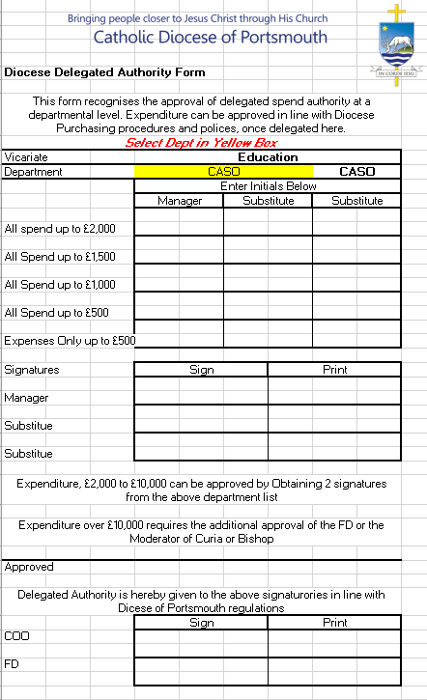

**Appendix B Purchase Order request / Purchase Requisition**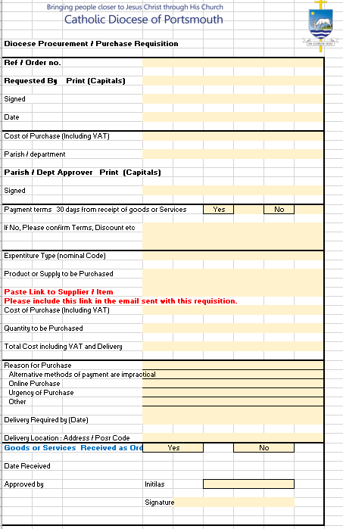

**Approvals**

The signatures below certify that this document has been reviewed and accepted demonstrating that the signatories are aware of all requirements contained herein and are committed to ensuring their provision.

|  |  |  |  |
| --- | --- | --- | --- |
| Name | Signature | Position | Date |
| Prepared by | Keith Harvey |  | Financial Controller | Jan 2021 |
| Reviewed by | Mark Van Wijk |  | Director of Finance and IT | Jan 2021 |
| Reviewed by | Heather Hauschild |  | Chief Operating Officer | Jan 2021 |
| Reviewed by |  |  | Finance Audit and Risk Committee | Jan 2021 |
| Approved by |  |  | Trustees |  |
| Reviewed by |  |  | Senior Leadership Team | Jan 2021 |

**Amendment Record**

This document is reviewed to ensure its continuing relevance to the systems and processes that it describes. A record of contextual additions or omissions is given below.

|  |  |  |  |
| --- | --- | --- | --- |
| Page No. | Context | Revision | Date |
|  |  |  |  |

1. **Credit Card Policy (Curia)**

*And my God will supply every need of yours according to his riches in glory in Christ Jesus. Philippians 4:19*

|  |  |
| --- | --- |
| **Operative date:** | December 2020 |
| **Author:** | Financial Controller |
| **Diocese of Portsmouth owner:** | Finance Director |
| **Review date:** | January 2024 |
| **For action by:** | All Curia Credit Card Users and approvers of Curia Credit Card Expenditure. |
| **Policy statement:** | This policy is for Curia Credit Cards only.  This Policy sets out the Principles, responsibilities and process for Procurement by Credit Card.  The policy will provide guidance on how to obtain a credit card, how the credit card may be used and the processes that must be followed when using the card and reporting on credit card expenditure. |
| **Responsibility for dissemination to new staff:** | Finance, Credit Card Approvers and Holders |
| **Mechanisms for dissemination:** | This policy will be available on the Department of Administration drive within the network. |
| **Training implications:** | Policy will be highlighted to all department heads and new credit card holders during induction. |
| **Resource implications** | There are no resource implications |

**Introduction**

The Diocese may provide clergy or employees with credit cards. Credit cards should not be provided to volunteers.

Credit cards are to be used for diocesan expenditure only. Credit cards should not be used to pay for personal expenditure.

Using a credit card is a more secure form of payment than paying with cash. Having a credit card can help track and process expenditure, prevent fraud and make payments more efficiently.

Purchasing with a credit card is a more vulnerable form of payment than payment via invoice and should not be used when invoice payment is possible.

This policy provides guidance and procedures that will ensure only appropriate clergy and employees are provided with credit cards, clergy and employees with diocesan credit cards use them properly and securely and are aware of their responsibilities.

### **Purpose and Scope**

This policy applies to all clergy or employees who have been provided a diocesan credit card. It also applies to clergy or employees who have the right to approve the use of a credit card and approve credit card expenditure.

### **Roles & Responsibilities**

Heads of Vicariate, Tribunal, Chancery and the COO (to be called budget holders in this document) have ultimate responsibility for all expenditure within their areas of control, including Credit Card Expenditure.

Budget holders can request that named individuals are issued credit cards. Budget holders are responsible for ensuring only appropriate clergy or members of staff are issued a credit card for their area of responsibility.

Budget holders must be vigilant and act to manage expenditure within their area of control. Actions should include.

Monitoring which members of staff hold credit cards within their area of control and ensuring only appropriate members of staff have credit cards.

Reviewing and authorising monthly credit card returns considering accuracy and appropriateness of expenditure.

### **Procedures**

### **3.1 Obtaining a Credit Card**

* + Where appropriate, budget holders will request that staff members are issued credit cards.
  + Only staff members with authority to approve expenditure, as per the Expenditure Policy, can be issued a credit card.
  + To request a staff member receives a card the Credit Card Request Form **(Appendix 1)** must be completed by a budget holder and sent to finance.
  + Credit cards will be issued by the Diocesan Finance Team.
  + Credit card users must read the Credit Card Policy and sign the Acceptance of Diocesan Credit Card form **(Appendix 3)** on receipt of the credit card.

### **Credit Card Use**

* + Payment via invoice, through the purchase ledger system, should be the normal process. Credit card usage is the exception, where the norm cannot be followed, due to medium (online purchase) or priority.
  + Credit card purchasers must adhere to the supplier selection process and other policies for good procurement as set out in the Expenditure Policy and Supplier Selection Procedure documents.
  + All credit card expenditure must be solely for the needs of the diocese.
  + Cards must not be used for non-authorized or personal expenses.
  + Never withdraw cash using the company credit card.

### **3.3 Credit Card Limit**

* + Credit card limits for cards belonging to individuals will be set at £200.
  + In rare circumstances credit limits may be adjusted based on specific identified needs.
  + The Diocese will have two Central Credit cards each with limits set at £10,000.
  + These cards should be used when there is a requirement that larger transactions need to be processed through the credit cards.

Monthly returns **(Appendix 2)** need to be completed by all credit card holders and submitted to budget holders.

Receipts for all credit card transactions must be attached to the return.

Budget Holders must review the return and confirm approval the expenditure or query unusual items on the return.

Approved returns should be submitted to the finance department by the 7th of the following month.

Failure to submit the completed, approved return by the 7th of the following month may result in the card being withdrawn.

The monthly return of Budget Holders must be reviewed and approved by the COO.

**3.4 Central credit Card**

To make use of the Central cards please complete the Purchase Requisition form **Appendix 4** and submit the forms once approved to PA to the COO or to the Administrative Service Manager.

Central credit card details will not be shared, by the PA to the COO.

**4 Security**

* Individuals named on the credit card are responsible for ensuring the safety of the card.
* Named individuals should not leave the card unattended or easily accessible.
* Card details should not be shared with anyone, from within or outside of the diocese.
* If the card is lost or stolen report it to Lloyds immediately by calling 0800 096 4496 immediately. Once Lloyds have been informed contact the senior accounts technician at accounts@portsmouthdiocese.org.uk.

**Appendix 1: Credit Card request Form**

**Request for a Diocese Credit Card for Procurement**

The Diocese may provide clergy or employees with credit cards to be used for diocesan or parish-related expenditure only.

Using a credit card is a more secure form of payment than paying with cash. Having a credit card can help track and process expenditure, prevent fraud and make payments more efficiently.

Purchasing with a credit card is a more vulnerable form of payment than payment via invoice and should not be used when invoice payment is possible.

This policy provides guidance and procedures that will ensure employees with diocesan credit cards use them properly and securely and are aware of their responsibilities.

Individuals Credit card limit will be set at £200.

Please could you approve ______________________________________________ use of a Diocese Credit Card for Procurement purposes.

The Cardholder

Will submit monthly approved returns to Finance, with supporting invoices and receipts. Failure to produce receipts and the return by the 5th of the following month may result in the card being withdrawn. Re-imbursement to the Diocese may be reclaimed from the cardholder where this requirement is not met.

Will be used for diocesan or parish-related expenditure only.

Will comply with Credit Card Policy.

Will accept responsibility for the security of the credit card and its use.

Will not share card details with anyone, from within or outside of the diocese.

Will prioritise the use of established suppliers and their payments terms.

Will never use the card to withdraw cash.

Will never use the card for personal expenditure.

**Budget Manager**

Name ____________________________________________ Signature __________________________________

**Approved - Finance**

Name ____________________________________________ Signature __________________________________

**Appendix 2 – Credit card Return – Diocese (Also available as an Excel spreadsheet)**

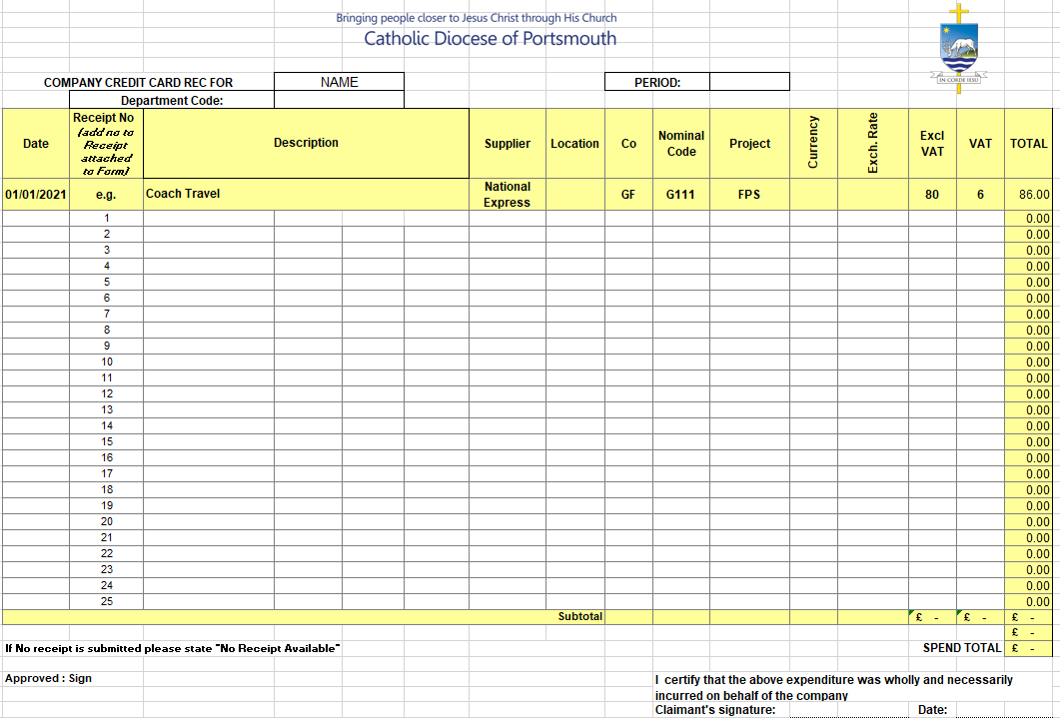

**Appendix 3**

**Acceptance of a Diocese Credit Card for Procurement**

I ________________________________________________________ have received the following credit card.

(Photocopy of the Front and reverse of the card attached.

I will incur expenditure in line with the Policy above, which will be for the purpose of the Parish / Diocese and will not be for Personal Use, and take due care to:

* Protect it to the best of your ability. Do not leave it unattended or give it to unauthorized people (e.g., friends, family, colleagues) even just to hold.
* Report it stolen or lost as soon as possible. If, for example, there is a break-in at your home and your company card is taken, you need to file a police report and call our accounting department immediately.
* Use it only for approved reasons. Follow the instructions in this policy and the employee card agreement, and do not use the card for personal or unauthorized expenses, even if you intend to compensate the charges later.
* Document all expenses above, as you spend and send monthly credit card reports.

Credit Card may be cancelled or removed when returns are not submitted to Finance promptly for processing.

I agree to re-imburse any expenditure to the Diocese that has not been in line with the above and give my permission for this to be deducted from Pay.

Signed ____________________________________________

Date ­­­­­­­­­­­­­­­­­­­­­­­­­_____________________________

**Appendix 4 : Central Cards – Purchase Requisition**

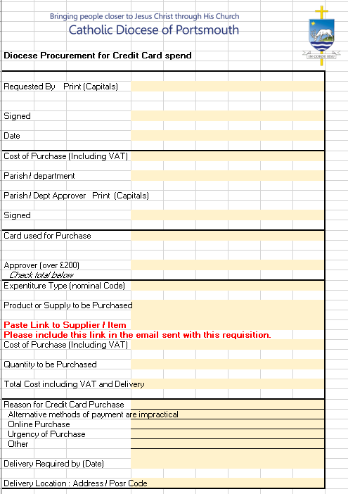

1. **Income Policy (Curia)**

*On the first day of every week, each of you is to put something aside and store it up, as he may prosper, so that there will be no collecting when I come. 1 Corinthians 16:2*

|  |  |
| --- | --- |
| **Subject and version number of document:** | Income Policy Curia version 1.0 |
| **Serial number:** | 0001 |
| **Operative date:** | February2021 |
| **Author:** | Financial Controller |
| **Diocese of Portsmouth owner:** | Financial Controller |
| **Links to other policies:** |  |
| **Review date:** | February 2024 |
| **For action by:** | All |
| **Policy statement:** | This policy relates to Curia income only.  This policy determines the controls required for acceptance and approval of income. |
| **Responsibility for dissemination to new staff:** | The policy will be provided to new staff on induction |
| **Mechanism for dissemination:** | This policy will be available on the Department of Administration drive within the network. |

|  |  |
| --- | --- |
| **Training implications:** | Staff and volunteers need to be aware of the content of the policy, the policy will be available on the Department of Administration drive within the network. |
| **Resource implications** | Communication of the policy is the key requirement; Files recoding the approval of Capital and restricted funds income will need to be maintained. |
| **Further details and additional copies available from:** | Please contact the Financial Department for further information on this policy. |
| **Consultation process** | The Finance department have developed this process in conjunction with Estates and Communications / Grants team |
| **Approved by:** | Finance Committee |
| **Date approved:** | February 2021 |

### Website upload:

|  |  |  |
| --- | --- | --- |
| Website |  |  |
| Keywords: | *Income, Grants, Donation, Award, Legacy* | |

**Amendments summary:**

|  |  |  |  |  |
| --- | --- | --- | --- | --- |
| Amend No | Issued | Page(s) | Subject | Action Date |
| 1 |  |  |  |  |
| 2 |  |  |  |  |
| 3 |  |  |  |  |
| 4 |  |  |  |  |
| 5 |  |  |  |  |

**Review log:**

Include details of when the document was last reviewed:

|  |  |  |  |  |
| --- | --- | --- | --- | --- |
| Version Number | Review Date | Name of Reviewer | Ratification Process | Notes |
| 1.0 | Jan 2021 |  |  |  |
|  |  |  |  |  |
|  |  |  |  |  |
|  |  |  |  |  |

1. **INTRODUCTION** 
   1. This policy determines the procedures required for the approval of income to be received by the diocese.
   2. This policy applies to Curia income only.
   3. It is important that income is scrutinized and approved before it is accepted. Often by accepting income, the diocese is committing to deliver a service and/or incur additional expenditure. As such accepting income represents the same risk to the diocese as approval of expenditure.
   4. The income policy will ensure that information is captured that will enable the diocese to manage restricted funds.
   5. The income policy also specifies the debtor collection process and responsibilities.

### **Purpose and Scope**

* + 1. The policy applies to all Clergy and Staff that receive money on behalf of the diocese.
    2. This policy does not relate to unrestricted donations or legacies.
    3. This policy relates to income that commits the diocese to the delivery of a service or commits the diocese to incur expenditure. This includes all grant income, all restricted income, government allocations for school maintenance and Service Level Agreements.
    4. This policy also relates to income where collection of the income should be managed and reported upon. This includes the Schools Levy income, Schools Building Fund income, Seminar Fees and chargeable safeguarding fees.

### **ROLES AND RESPONSIBILITIES**

* 1. Heads of Vicariate, Tribunal, Chancery and the COO (to be called budget holders in this document) have ultimate responsibility for all income within their areas of control.
  2. Budget holders can delegate authority to approve income to named individuals. Budget holders are responsible for ensuring only appropriate clergy or members of staff have delegated authority to approve income within their area of responsibility.
  3. Budget holders must be vigilant and act to manage income within their area of control. Actions should include;
* Monitoring which members of staff hold delegated authority to approve income within their area of control and ensuring only appropriate members of staff have delegated authority.
* Reviewing monthly management accounts to ensure income does not vary materially from the authorised budget.
* Regularly review aged debtor reports
  1. **Authority to Approve Transactions**
  2. Income of up to £2,000
  3. Budget Holders can approve income up to the value of £2,000 personally.
  4. Budget holders can delegate authority to approve income to named individuals.
  5. The budget holder will set a maximum value of transaction that each named individual can authorise. The maximum value can be tailored for each named individual and can be set between £1 and £2,000.
  6. To formally delegate authority to named individuals the Delegation of Income Authority Form needs to be completed for each programme. Only people named on the form are permitted to approve income for a programme. An example of a completed Delegation of Income Authority Form is included as Appendix A to this document.
  7. Completed Delegation of Income Authority forms will be stored by the finance department.
  8. The Finance Department must be notified immediately of any changes to the authorities to approve income.

Income of £2,000 - £10,000

* 1. A budget holder and the nominated individual must both approve transactions between £2,000 and £10,000 in value.

Income of £10,000 and £50,000

* 1. After the approvals in 3.12 have been received, the transactions must also be approved by the COO or Director of Finance.

Income in excess of £50,000

* 1. After the approvals in 3.13 have been received, the transactions must also be approved by the FAR.
  2. The value of the income should be the total contract value over the expected life of the arrangement.

Schools Building Fund Grants

* 1. Schools Building Fund grants are not diocesan income. The diocese receives and holds money on behalf of schools. The diocese’s liability is limited to 10% of the cost of the capital project.
  2. To reflect the limitation in the liability of the diocese the level of approval will be reduced.
  3. The approvals will be as above but based on a deemed value of the grant. The deemed value be

Deemed Value of Grant = 10/90 X the value of the grant.

### **PROCESS**

**Requesting the issue of a One-off Invoice**

* 1. The finance team will generate all invoices for income (to be called sales invoices).
  2. To request that the finance team generate a sales invoice the Sales Invoice Request form should be completed and emailed to [accounts@portsmoutdiocese.org.uk](mailto:accounts@portsmoutdiocese.org.uk).
  3. The Sales Invoice Request Form is included as appendix B in this document.
  4. When submitting the Sales Invoice Request Form, the email trail should demonstrate approval by the prerequisite team members. Section three of this document defines the required levels of approval.
  5. Sales Invoice Request Forms received by Tuesday at 5pm will be processed by Friday at 5 pm.

**Supporting Documentation**

* 1. When submitting the Sales Invoice Request Form the final contract between the diocese and the funder must be submitted with the Sales Invoice Request Form.
  2. For grants without a formal contract the application for funding and the award letter must be submitted.

**Restricted Income**

* 1. Using the information submitted on the Sales Invoice Request Form the diocese will identify restricted income and begin the process of monitoring compliance with the requirements attached to the restricted income.
  2. A Sales Invoice Request Form must be completed for all grants, even those awarded to parishes, or those awarded as government contributions to the cost of maintaining schools, to facilitate the monitoring of restricted income.

**Bulk Invoicing**

* 1. Where the finance team will be producing a large number of invoices for standard items (like batches of schools building fund invoices or batches of invoices for seminar attendance) then colleagues can request to be issued a bulk invoice request form that can be used to request the bulk generation of invoices.

**Donations and other income**

* 1. Staff and clergy within the curia will receive ad hoc donations or small payments for services such as tribunal or marriage and family life.
  2. These payments should be sent to the diocesan finance team or banked into the local Lloyds branch into the diocese general account (sort code; 30-93-04, Account Number 00865746).
  3. When payments of this form are made the Donations and Other Income form should be completed and submitted to the finance team on the date the payment is made.

**Debt Collection**

* 1. This debt collection process is for the collection of funds owed in relation to invoices that have been issued. A separate policy will be developed for managing loans and other forms of debt.
  2. A monthly aged debtor reports will be provided to budget holders.
  3. The aged debtor report will list all unpaid invoices and will show their age to give an indication of how long it has been since payment should have been received.
  4. Each month the finance team will review the aged debtors and if payment is delayed finance will contact the payor to query the delay.
  5. If the delay is due to procedural issues within the funders accounts payable process the finance team will attempt to resolve this situation and secure payment.
  6. If payment is being held up by the funder due to operational issues the finance team will contact the responsible person named on the Sales Invoice Request Form and agree a course of action to obtain payment of the invoice.
  7. The aged debtor report will be reported to FAR.

### **MONITORING THE EFFECTIVENESS OF THE POLICY**

* 1. Income records will be open to Audit annually by the External Auditors and on an ad-hoc basis by Funding Bodies.
  2. The primary role of this external audit is to report on the Charities financial statements and to carry out such examination of the statements and underlying records and control systems as are necessary to reach their opinion on the statements and to report on the appropriate use of funds.
  3. Funding Bodies will be reviewing how the Income provided to the Charity has been utilised and that any restrictions applied to the funding have been met. They may also anticipate Progress reports and Impact analysis on the result of the project.
  4. Budget Holders will be able to review income incurred on a regular basis against their departments budgets and advise of any unexpected transactions.

### **REVIEW**

* 1. This document may be reviewed at any time at the request of either the staff or management, or in response to changes in legislation, but will automatically be reviewed after twelve months and thereafter on a biennial basis.
  2. The signatures below certify that this document has been reviewed and accepted, demonstrating that the signatories are aware of all requirements contained herein and are committed to ensuring their provision.

|  |  |  |  |
| --- | --- | --- | --- |
| Name | Signature | Position | Date |
| Prepared by | Keith Harvey |  | Financial Controller | Jan 2021 |
| Reviewed by | Mark Van Wijk |  | Director of Finance and IT | Jan 2021 |
| Reviewed by | Heather Hauschild |  | Chief Operating Officer | Jan 2021 |
| Reviewed by |  |  | Finance Audit and Risk Committee | Jan 2021 |
| Reviewed by | Karena Fulford |  | Head of People | Jan 2021 |
| Reviewed by |  |  | Senior Leadership Team | Jan 2021 |
| Approved by |  |  | Trustees |  |

### **Amendment Record**

* 1. This document is reviewed to ensure its continuing relevance to the systems and processes that it describes. A record of contextual additions or omissions is given below.

|  |  |  |  |
| --- | --- | --- | --- |
| Page No. | Context | Revision | Date |
|  |  |  |  |

### **REFERENCES AND LINKS TO OTHER DOCUMENTS (where applicable)**

* 1. Delegation of Income Authority Form
  2. Sales Invoice Request Form
  3. Donations and Other Income form

**Appendix A – Delegation of Income Authority Form**

**Appendix B – Sales Invoice Request Form**

**Page 1 – General Invoice Information**



**Appendix B – Sales Invoice Request Form –**

**Page 2 – Additional Information for Monitoring Restricted Funds**



**Appendix C – Donations and Other Income Form**



**Supplier Selection Procedure**

1. **INTRODUCTION AND PURPOSE**
   1. The prescribed procedure for supplier selection should ensure the Diocese receives value for money and can demonstrate probity in procurement decisions.

|  |  |
| --- | --- |
| **Subject and version number of document:** | Supplier Selection Procedure version 1.0 |
| **Serial number:** | 0001 |
| **Operative date:** | February 2021 |
| **Author:** | Financial Controller |
| **Diocese of Portsmouth owner:** | Financial Controller |
| **Links to other policies:** |  |
| **Review date:** | February 2024 |
| **For action by:** | All clergy or employees who are buying goods or services of any size. |
| **Policy statement:** | The prescribed procedure for supplier selection should ensure the Diocese receives value for money and can demonstrate probity in procurement decisions.  The supplier selection procedure specifies differing levels of scrutiny for transactions of different values. Transactions of a greater value require increased scrutiny when selecting a supplier.  The Supplier Selection Procedure must be followed for all orders of goods or services. |
| **Responsibility for dissemination to new staff:** | The policy will be provided to new staff on induction |
| **Mechanisms for dissemination:** | This procedure will be available on the Department of Administration drive within the network. |

|  |  |
| --- | --- |
| **Training implications:** | The policy will be available on the Department of Administration drive within the network. |
| **Resource implications** | The supplier selection procedure should ensure the diocese makes the best use of available resources. |
| **Further details and additional copies available from:** | Please Contract the Financial Department for further information on this policy. |
| **Consultation process** | The Finance department have developed this process, to meet current authority limits and future systems requirements. |
| **Approved by:** | Finance Committee |
| **Date approved:** | February 2021 |

### Website upload:

|  |  |  |
| --- | --- | --- |
| Website |  |  |
| Keywords: | *Expenditure, Purchase, Order, Payment, Supplier, Selection, Tender, Close Relationship* | |

**Amendments summary:**

|  |  |  |  |  |
| --- | --- | --- | --- | --- |
| Amend No | Issued | Page(s) | Subject | Action Date |
| 1 |  |  |  |  |
| 2 |  |  |  |  |
| 3 |  |  |  |  |
| 4 |  |  |  |  |
| 5 |  |  |  |  |

**Review log:**

Include details of when the document was last reviewed:

|  |  |  |  |  |
| --- | --- | --- | --- | --- |
| Version Number | Review Date | Name of Reviewer | Ratification Process | Notes |
| 1.0 | Jan 2021 |  |  |  |
|  |  |  |  |  |
|  |  |  |  |  |
|  |  |  |  |  |

### **SCOPE**

* 1. The Supplier Selection Procedure must be followed for all orders of goods or services.

### **ROLES AND RESPONSIBILITIES**

* 1. Budget holder are ultimately responsible for all expenditure within their area of authority. This will include material supplier selection.
  2. Performance of the tender process can be delegated but authority to approve supplier selection is reserved for specified individuals. The table below shows who is able to authorise supplier selection.
  3. 

### **PROCESS**

* 1. Staff members and clergy making a purchasing decision must undertake a prescribed process when selecting a supplier.
  2. The table below provides a high-level overview of the levels of scrutiny required when selecting a supplier.
  3. Below the table, the remainder of this section expands on the detail in the table and provides guidance on the process.
  4. 

**Supplier Selection Procedure**

* 1. The supplier selection procedure recognises that transactions of a greater value require increased scrutiny when selecting a supplier.
  2. The transaction value will determine the required level of scrutiny.
  3. The transaction value should be the value of the complete lifecycle of the transaction and cannot be broken into smaller packets to reduce the work required when selecting a supplier.

**Purchase or contract less than £2,000**

* 1. If the total value of the purchase is expected to be less than £2,000 then there is no need to formally evidence the work done when choosing a supplier, but the purchaser must act to ensure that the Diocese is receiving value for money.

**Purchase or contract between £2,000 and £10,000**

* 1. If a contract is expected to be in excess of £2,000 purchasers should undertake a review, and provide evidence of the review, of different purchase options.
  2. This process should consider at least three options.
  3. The supplier selection form can be used to document this review.
  4. A completed supplier selection form is included as appendix A to this document.

**Purchase or contract in excess of £10,000**

* 1. A tender process should be designed for all contracts in excess of £10,000.
  2. A tender process should be tailored to meet the needs of the specific purchase.
  3. The tender process should involve greater scrutiny and wider consultation for larger contracts.
  4. Section 5 in this document provides detailed guidance on completing a formal tender process.

**Sensitive or Contentious Contracts**

* 1. Sensitive or contentious contracts may need additional considerations or approval when ordering or tendering. Budget holders are responsible for deciding if a contract is sensitive or contentious and the required level of review.

**Close Relationships with suppliers/Conflicts of Interest**

* 1. If a close relationship exists with a supplier or a conflict of interest exists in the purchasing decision then the **close relationship section** of the supplier selection form must be completed irrespective of the transaction size.
  2. The close relationship or conflict of interest must be reviewed by the Finance Director and approved before the order can be placed.
  3. Section 6 below discusses close relationships and conflicts of interests with suppliers.

1. **TENDER PROCESS** 
   1. This section describes the potential stages of a formal tender process.
   2. A formal tender process could include all or some the stages below.
   3. Select Tender Panel – A tender panel should be chosen that provides expertise that will enable a successful completion of the tender process.
   4. The size and constituency of the tender panel will depend on the size, complexity, and nature of the purchase.
   5. The tender panel would be involved in all or some of the following stages.
   6. Long-list of Potential Suppliers
   7. The tender panel and other knowledgeable stakeholders should be asked to provide prospective suppliers to be included on the long-list.
   8. Tender Specification and Invitation to Tender
   9. A document should be prepared inviting suppliers to tender. This document should describe in detail the desired goods or services, and the aims and priorities of the diocese when embarking on this project.
   10. Prospective suppliers should be asked to respond in writing if they would like to be considered for the contract.
   11. The document should specify in detail the information that should be provided by the supplier when responding to the Invitation to Tender and a deadline for providing the information.
   12. It has been shown that projects where purchasers have prepared written specifications are more likely to report a successful outcome.
   13. Review of Tender Document and Shortlisting
   14. Review the tender documents received from prospective suppliers against the criteria set out in the tender briefing document and select a short list of favourable suppliers.
   15. The supplier selection form can be used as a tool for this review.
   16. Presentation
   17. Short listed suppliers could be invited to present and discuss their proposal with the purchaser or a panel.
   18. A presentation and face to face meeting will give the purchaser a chance to ask questions.
   19. References
   20. It may be appropriate to ask the supplier to provide references, former customers who could be asked to feedback on their experience with the supplier.
2. **CLOSE RELATIONSHIPS WITH SUPPLIERS OR CONFLICTS OF INTEREST**
   1. If a conflict of interest exists for anyone involved in a purchasing decision then this must be disclosed.
   2. If a close relationship exists between a prospective supplier and the Diocese, the purchaser, a Trustee or another member of staff, then this relationship must be disclosed.
   3. A close relationship should be interpreted widely; any relationship that a third party might think affects the purchasing decision should be considered a close relationship. This relationship could be a relation, friend, business associate or if the Diocese has been using the supplier for a long time.
   4. Once a close relationship or a conflict of interest has been identified the purchaser must conclude if the supplier must be excluded from the selection process. In deciding this they should consider if they would be able to ensure the purchasing decision is unbiased. They must also consider if people external to the Charity learnt of the relationship, would it bring the Diocese into disrepute.
   5. If it is decided that the Diocese would be able to contract with this supplier then the purchaser needs to record in the notes section of the supplier selection form the procedures that have been put in place to ensure that this relationship or conflict of interest has not affected the purchasing decision.
   6. If the relationship is directly with the purchaser then they cannot make the final supplier selection decision. In this situation they must recuse themselves from the selection panel when the decision is being made.
   7. Failure to document a close relationship may lead to disciplinary action.

### **TRAINING**

* 1. Circulation of this policy and availability of the forms are key. Once new Systems are acquired a separate training initiative will be developed to launch the new system, as the supplier will need to be on the system before a Purchase Order can be raised..

### **MONITORING THE EFFECTIVENESS OF THE POLICY**

* 1. Tender Reviews, Supplier Selection forms, Purchase Requisitions, Orders, Invoices and Payments will be open to Audit annually by the External Auditors and on an adhoc basis by HMRC.
  2. The primary role of this external audit is to report on the Charities financial statements and to carry out such examination of the statements and underlying records and control systems as are necessary to reach their opinion on the statements and to report on the appropriate use of funds.
  3. HMRC have the ability for the same and to impose Fines, Interest, and penalties where non-compliance to HMRC rules is established.
  4. Budget Holders will be able to review costs incurred on a regular basis against their departments and advise of any unexpected transactions.

### **REVIEW**

### This document may be reviewed at any time at the request of either the staff or management, or in response to changes in legislation, but will automatically be reviewed after twelve months and thereafter on a biennial basis.

### The signatures below certify that this document has been reviewed and accepted demonstrating that the signatories are aware of all requirements contained herein and are committed to ensuring their provision.

|  |  |  |  |
| --- | --- | --- | --- |
| Name | Signature | Position | Date |
| Prepared by | Keith Harvey |  | Financial Controller | Jan 2021 |
| Reviewed by | Mark Van Wijk |  | Director of Finance and IT | Jan 2021 |
| Reviewed by | Heather Hauschild |  | Chief Operating Officer | Jan 2021 |
| Reviewed by |  |  | Finance Audit and Risk Committee | Jan 2021 |
| Reviewed by | Karena Fulford |  | Head of People | Jan 2021 |
| Reviewed by |  |  | Senior Leadership Team | Jan 2021 |
| Approved by |  |  | Trustees |  |

### **AMENDMENT RECORD**

### This document is reviewed to ensure its continuing relevance to the systems and processes that it describes. A record of contextual additions or omissions is given below.

|  |  |  |  |
| --- | --- | --- | --- |
| Page No. | Context | Revision | Date |
|  |  |  |  |

### **REFERENCES AND LINKS TO OTHER DOCUMENTS (where applicable)**

**Appendices**

**Appendix A – Supplier Selection Form**

